LAPORAN BUKTI PENGERJAAN UTS
NAMA:RAIS AMMAR BUDIMAN
NIM:2924016
MATKUL:UTS KECERDASAN BISNIS
- PROFILING BEFORE CLEANING
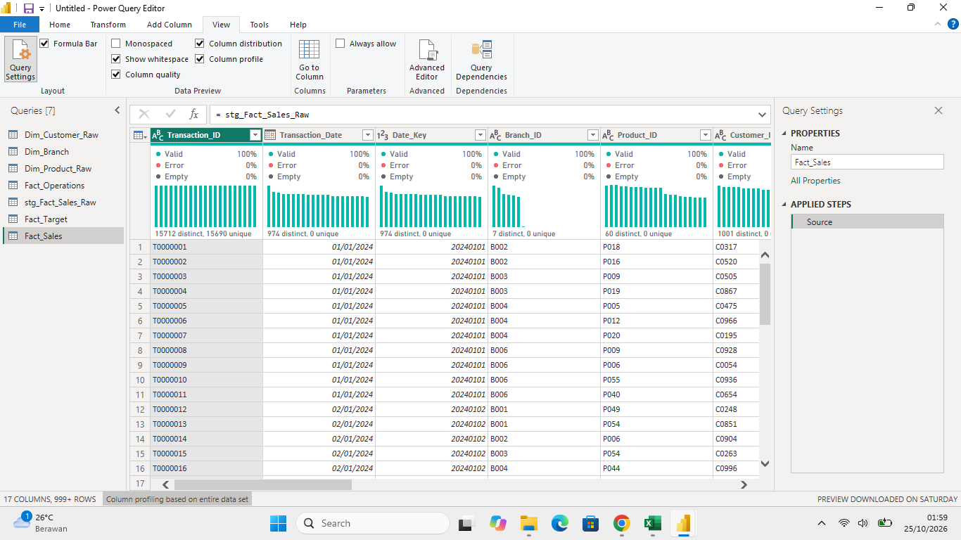
- REMOVE DUPLICATE
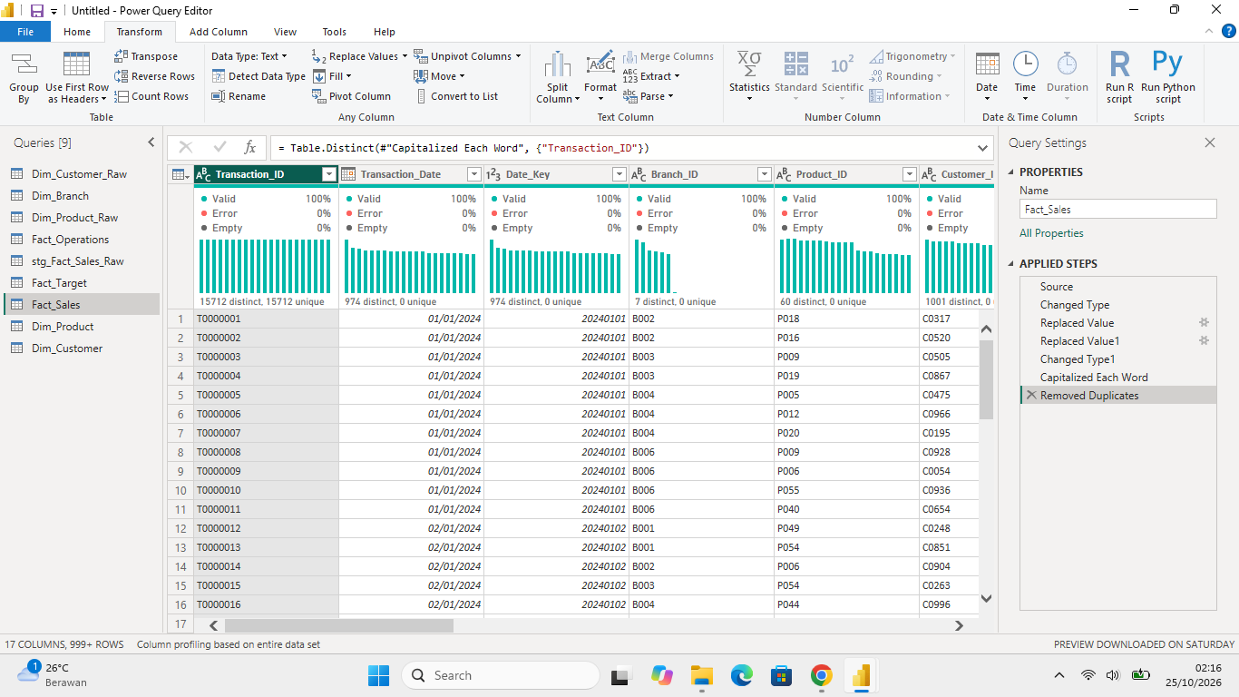
- APPLIED STEP
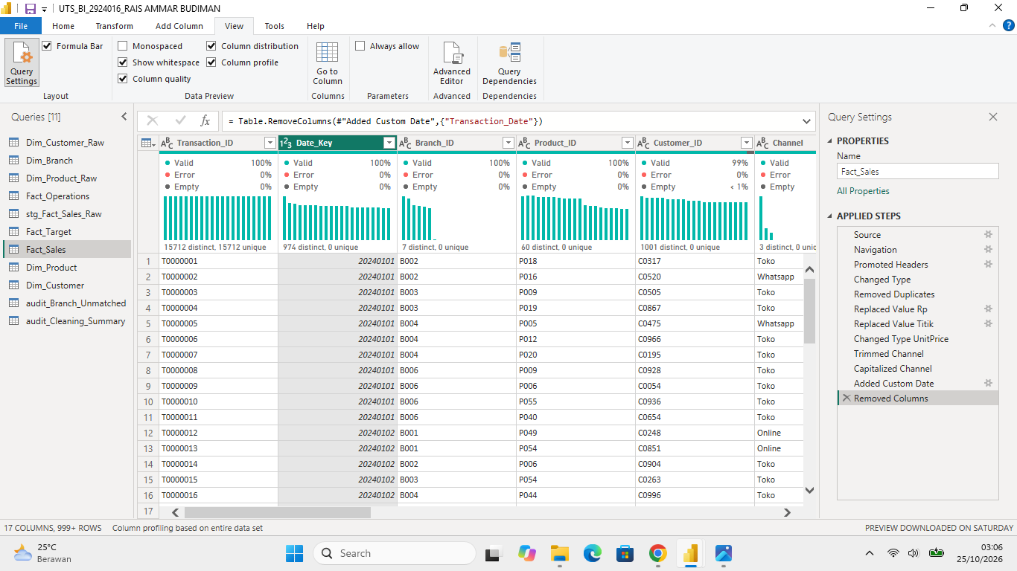
- CLEANING/NORMALIZE DATE
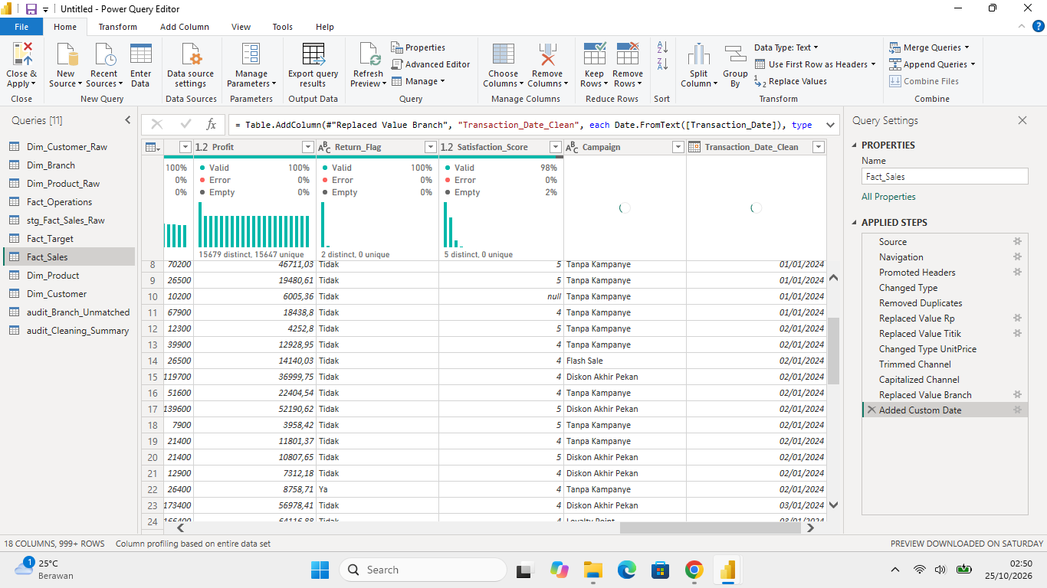
- AUDIT BRANCH ORPHAN KEY
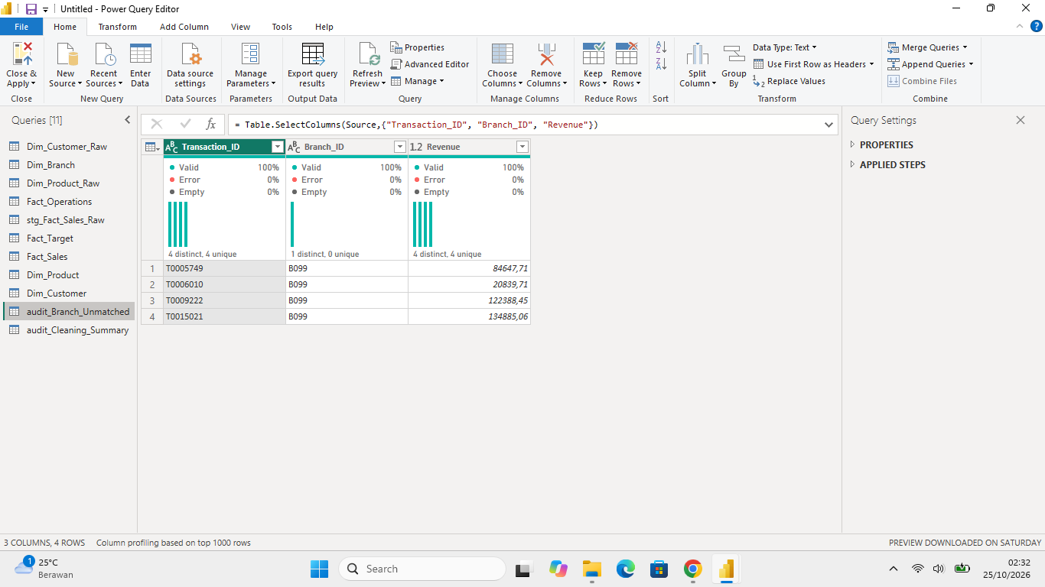

- BEFORE AND AFTER CLEANING
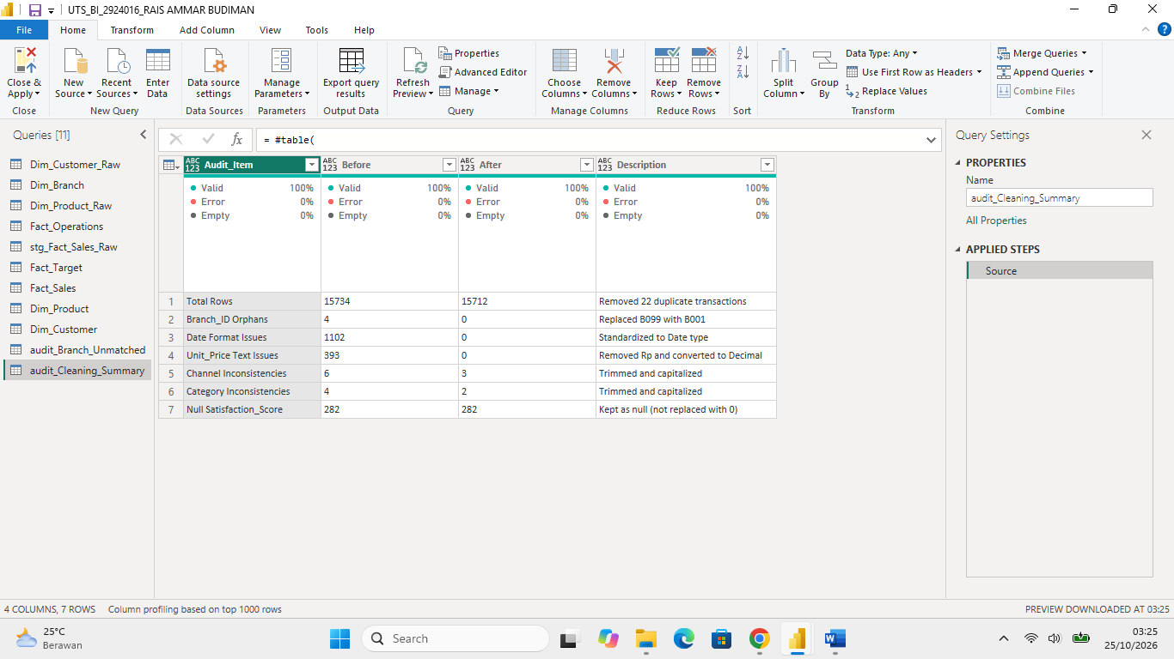
- PROFILING AFTER CLEANING
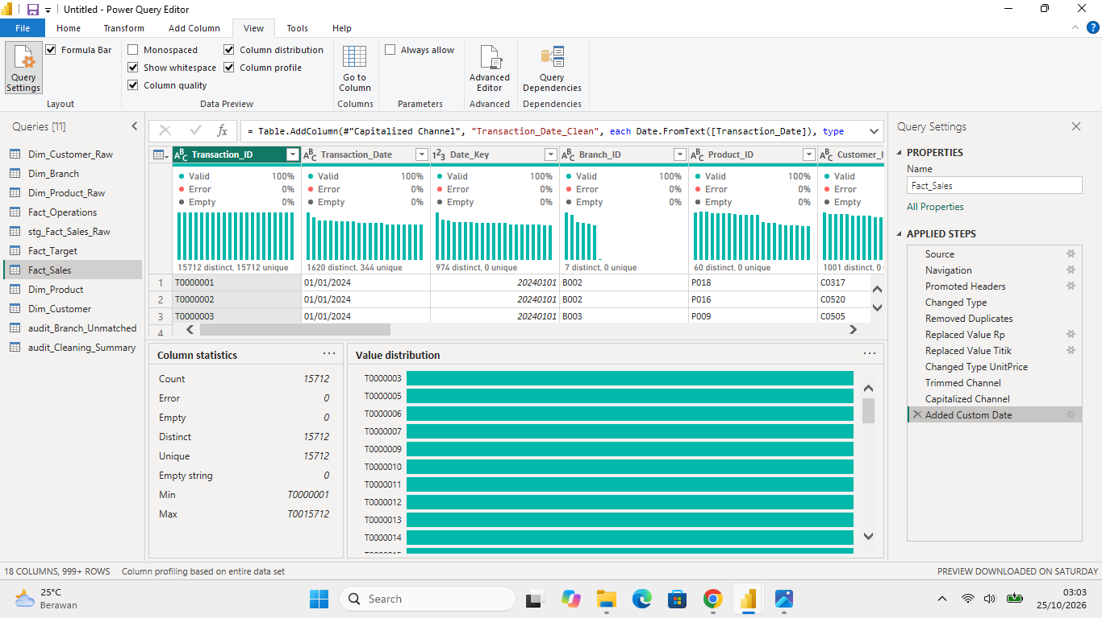
- STAR SCHEME
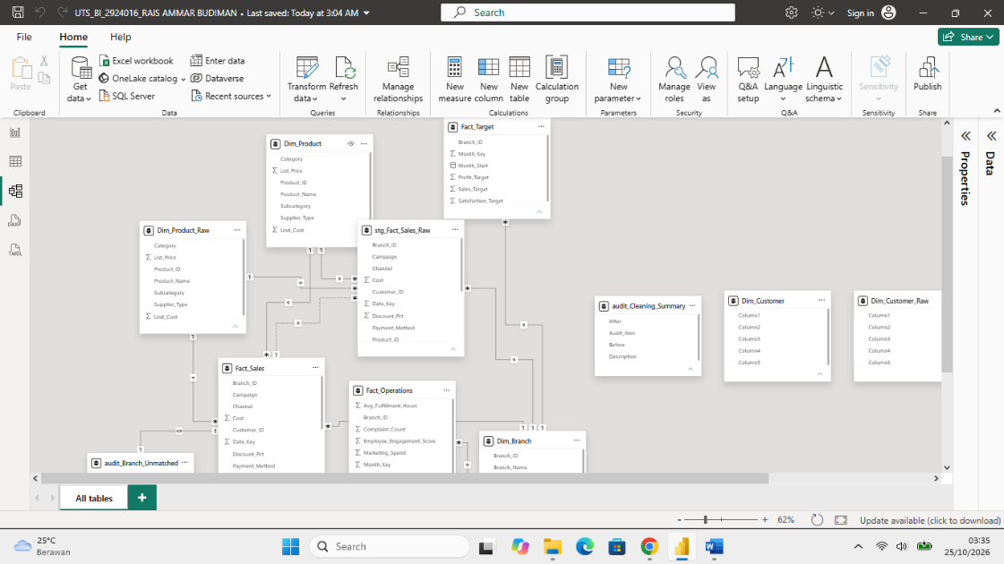

- ADD MEASURE AND DAX VALIDATION
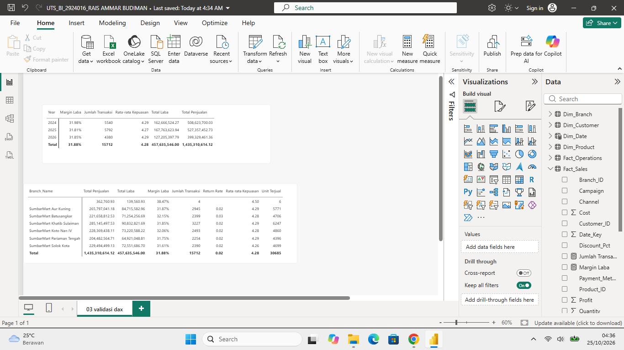
- EXECUTIVE DASHBOARD
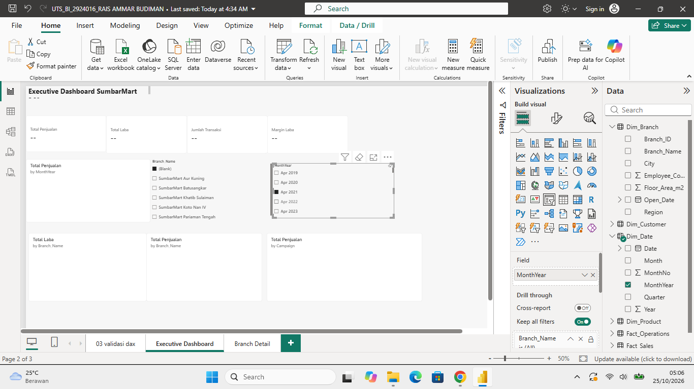
- DRILLTHROUGH
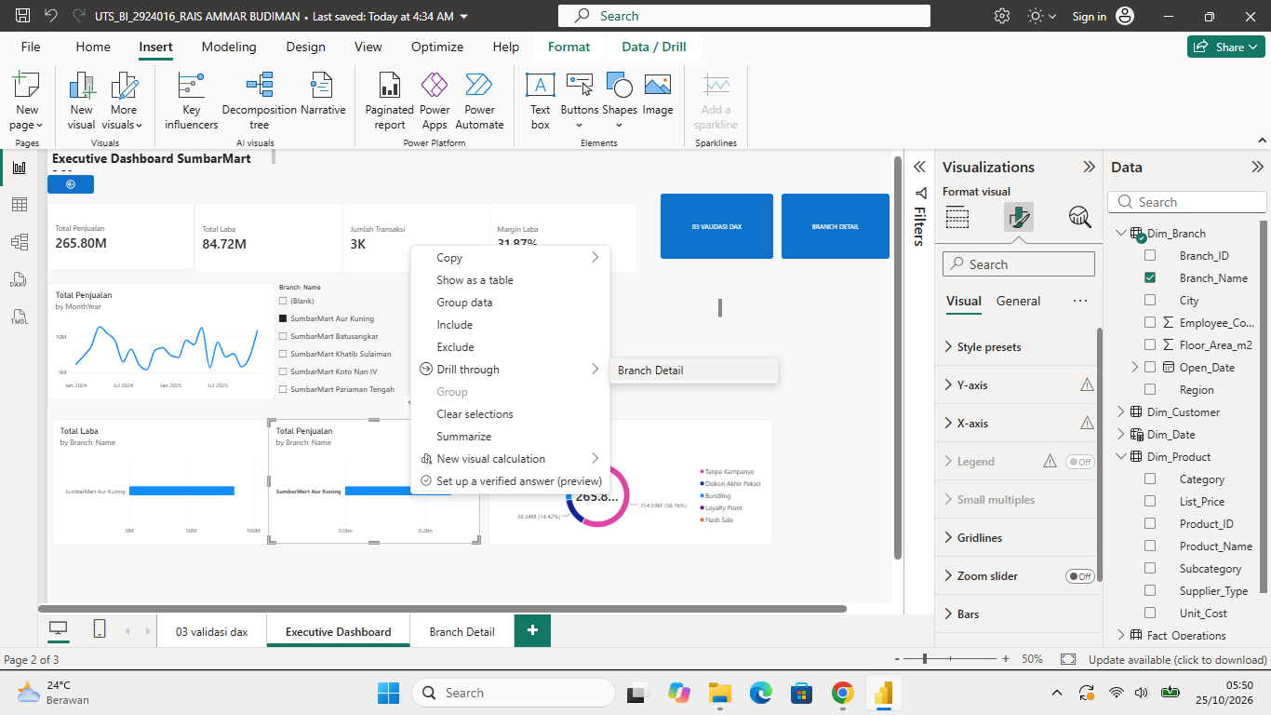

- PAGE NAVIGATION
